Hi everyone!

Today, whilst spending some time with the sales team, in effort to reduce the amount of clicks they perform to enter or process a sales order, we discovered a feature that will be a huge time saver, not just for them, but possibly you as well! Read on:

From a sales perspective, when they generate the order acknowledgement/confirmation, we found that each time they generated it - they would select several options on that window/screen that would make more sense if they were defaulted to those options so that they wouldn't have to update/change it each time.

It is possible for you to save these defaults. This is on a per person basis, so you may customize the defaults under your login to a manner that best suits your needs.

Example: In their case, they wanted the document format to always be default to P, the Reprint to be checked, and the Sales Order Selection the be Single (as shown below).
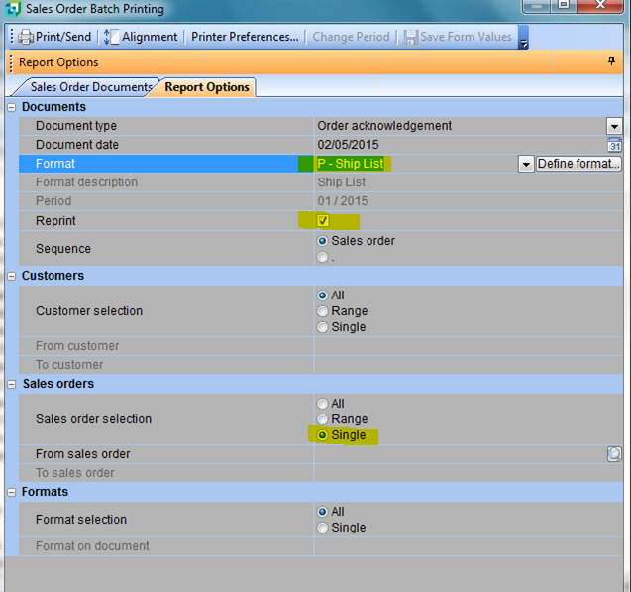

Once you make these selections to your defaulted likings, simply right click anywhere on that active window (make sure you're within the boundaries of that particular window/screen and NOT on any of the text/or clickable icons - so in the above example - anywhere in the grey area would work) and you will be presented with menu options (see image below).

If you click on Options, and then click "Save Form Values as Default" - the values that you've selected will always default, so you don't have to type them in over and over… Saving you a ton of time! This may work in other windows/screens of Syspro too, so don't be afraid to experiment. If you break it, I'll fix it, no worries…

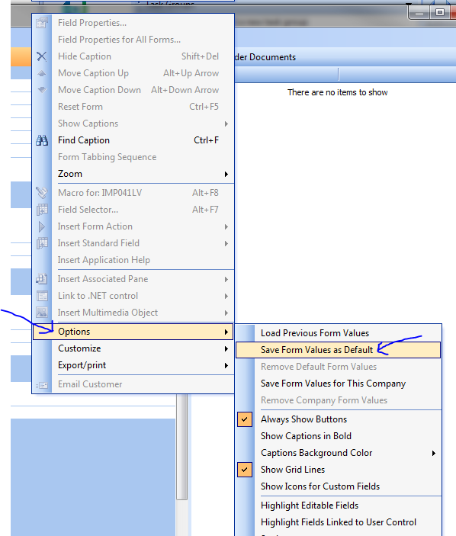

An alternative to selecting "Save Form Values as Default" would be to choose the one above that says "Load Previous Form Values". What that does is exactly that, it will load the values that you last entered on that screen - so if you're in a particular function that you maybe don't want to save certain values as default, but have a need to repeat the values for X amount of times, that option may be more appropriate.

Hopefully this information will help you customize your Syspro to your likings, so that it will save some unnecessary repetitive typing. Be sure to think about other processes that you do where this could come in handy, and see if the ability is there for you to set your default values…

