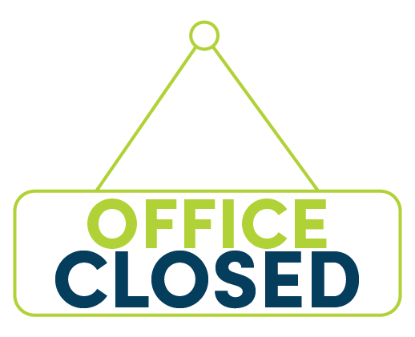

2025 Holiday Schedule

January 1st (Wednesday) – **New Year’s Day**

May 26th (Monday) – **Memorial Day**

July 4th (Friday) – **Independence Day**

September 1st (Monday) – **Labor Day**

November 27th (Thursday) - **Thanksgiving Day**

November 28th (Friday) – **Day After Thanksgiving Day**

December 25th (Thursday) – **Christmas Day**

December 26th (Friday) – **Day After Christmas (Floating Day)**